Distance -Time Graph practice question with solution:
A cyclist is training for a race and decides to record her journey using a GPS tracker. The distance-time graph of her 40-minute ride is provided below.
[Draw a distance-time graph on the board showing:
- 0-10 minutes: Steady increase in distance
- 10-15 minutes: Flat line (no change in distance)
- 15-30 minutes: Steeper increase in distance
- 30-40 minutes: Gradual increase in distance

- Interpret the data a) Describe what the cyclist was doing during the 10-15 minute period. b) During which time interval was the cyclist moving the fastest? Justify your answer using the graph.
- a) Calculate the average speed of the entire journey. b) Explain the difference between average speed and instantaneous speed.
- a) Determine the instantaneous speed of the cyclist at the 20-minute mark. Show your method. b) Compare the instantaneous speed at 20 minutes to the average speed of the entire journey. Explain any differences.
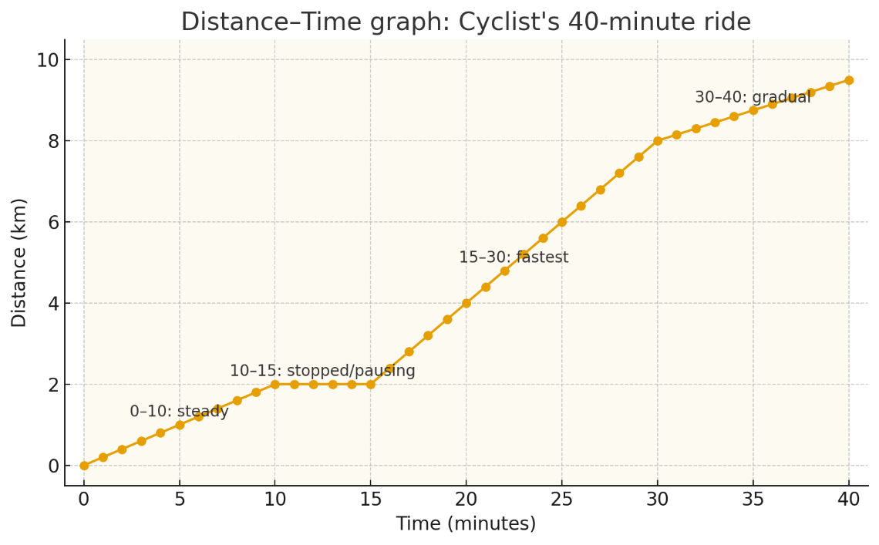

- 0–10 min: steady slope = 0.2 km/min (→ 12 km/h)
- 10–15 min: flat (no change in distance) = stopped/pausing
- 15–30 min: steeper slope = 0.4 km/min (→ 24 km/h)
- 30–40 min: gradual slope = 0.15 km/min (→ 9 km/h)
These produce a total distance of 9.50 km over 40 min.

Interpretations from the graph
a) What was the cyclist doing during 10–15 minutes?
She was stopped or paused — the distance stays constant (flat line), meaning no motion / zero speed during that interval (could be resting, waiting at traffic lights, adjusting equipment, etc.).
b) When was the cyclist moving fastest? Justify.
15–30 minutes. The graph is steepest there — slope (rise/run) is largest, meaning the highest speed. Numerically I used 0.4 km/min = 24 km/h for that segment.

Average speed — whole journey
We compute step-by-step.
Total distance = 9.50 km.
Total time = 40 minutes = 40 / 60 = 2/3 hours.
Average speed = total distance / total time
= 9.50 km ÷ (2/3 h)
= 9.50 × (3/2) km/h
= 14.25 km/h.
In m/s: 14.25 × 1000 / 3600 = 3.958... m/s (about 3.96 m/s).

Average speed vs instantaneous speed
Average speed = total distance / total time (summary over whole trip).
Instantaneous speed = speed at a single moment (slope of the d–t curve at that time; mathematically the derivative).
Average tells you the overall pace including stops/slow sections. Instantaneous tells you how fast she was going right then.

Instantaneous speed at 20 minutes
20 min lies in 15–30 min linear segment (constant slope). For that segment slope = 0.4 km per minute.
Compute:
- 0.4 km/min × 60 = 24 km/h instantaneous speed at 20 min.
- In m/s: 24 × 1000 / 3600 = 6.666... m/s (≈ 6.67 m/s).
Method shown: instantaneous speed = slope = Δdistance / Δtime for the tangent (or segment, since segment is linear). Because the 15–30 min segment is linear, the tangent slope = segment slope = 0.4 km/min.

Comparison: instantaneous at 20 min vs average
- Instantaneous at 20 min = 24.0 km/h.
- Average speed (whole trip) = 14.25 km/h.
Why the difference? Because the average includes the 10–15 min stop and slower parts (0–10 and 30–40 have lower speeds). Instantaneous at 20 min is only the speed during her fastest stretch, so it is higher than the overall average.

